Bahria University

Karachi Campus



LAB EXPERIMENT NO.

**7**

LIST OF TASKS

|  |  |
| --- | --- |
| TASK NO. | OBJECTIVE |
| 1 | Write the classes blow containing the given instance variables and methods, following the inherited hierarchy: |
| 2 | Write a program that inherits a class method Alien and Pirates from a parent class Human. The Human has its own specifications like, Human can sleep, Walk, talk etc. |
| 3 | Write a program that inherits a class name Produce, Cosmetics, Pharmacy, electronic item and cloth from a parent class Item. The Item class has its own features like, name and price etc. |
| 4 | Write a program that inherits a class named Pakistani, BBQ, Chinese, Fast Food and Beverages etc. from a parent class Item. |
| 5 | Write code according to the given guide. You must draw a class diagram first to start writing your code. |
|  |  |
|  |  |
|  |  |
|  |  |
|  |  |

Submitted On:

(Date: DD/MM/YY)

**Task No. 1:** Write the classes blow containing the given instance variables and methods, following the inherited hierarchy:

**Solution:**

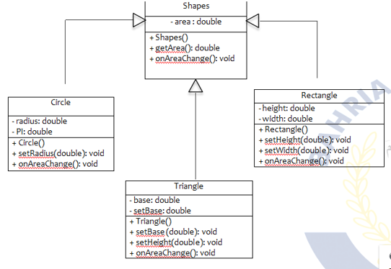

**Output:**

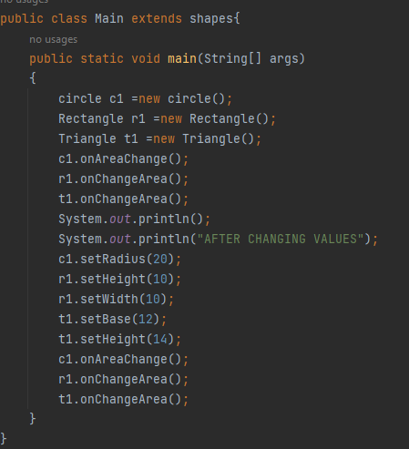

**Output:**

**Task No. 2:** Write a program that inherits a class method Alien and Pirates from a parent class Human. The Human has its own specifications like, Human can sleep, Walk, talk etc. The Alien and Pirates class inherit these functionalities as well as their characteristics, thus explaining the concepts of inheritance.

**Solution:**

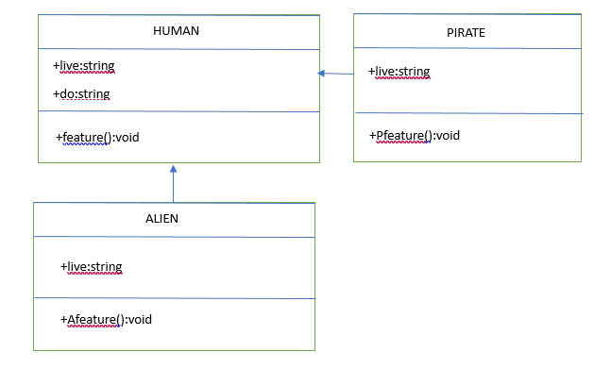

**Output:**

**Task No. 3:** Write a program that inherits a class name Produce, Cosmetics, Pharmacy, electronic item and cloth from a parent class Item, The Item class has its own features like, name and price etc.the child classes inheriting these functionalities as well as they have their characteristics, thus explaining the concepts of inheritance. Child classes like Produce, can have their own child classes i.e., Frozen and Fresh.

**Solution:**

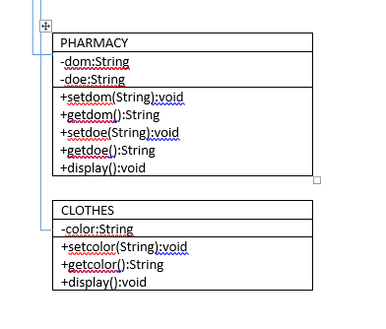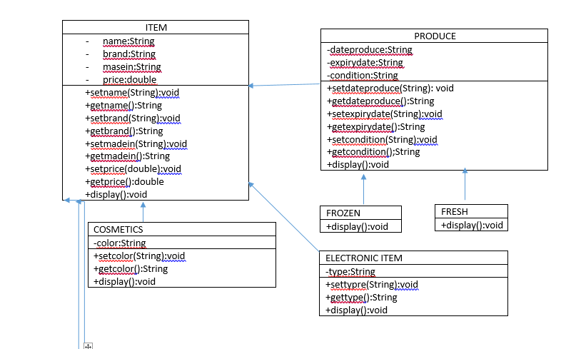

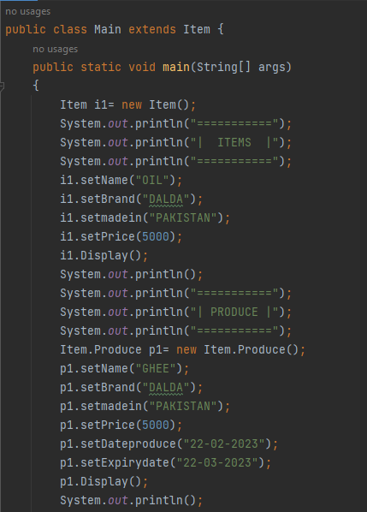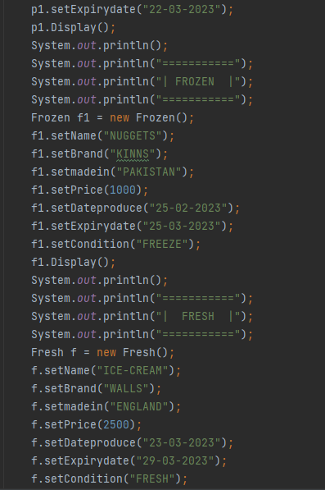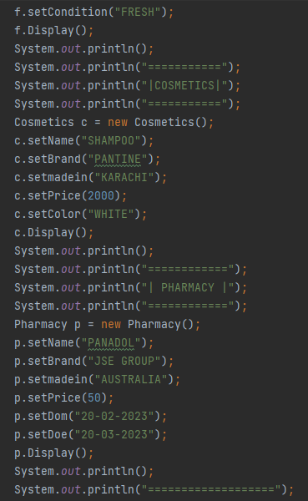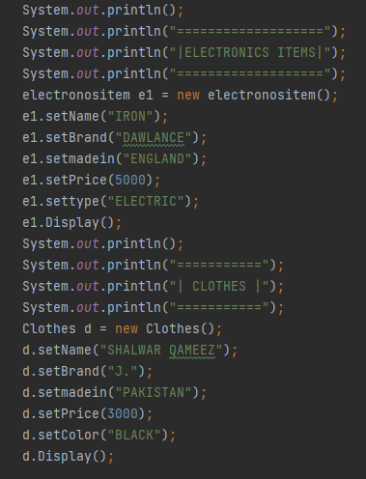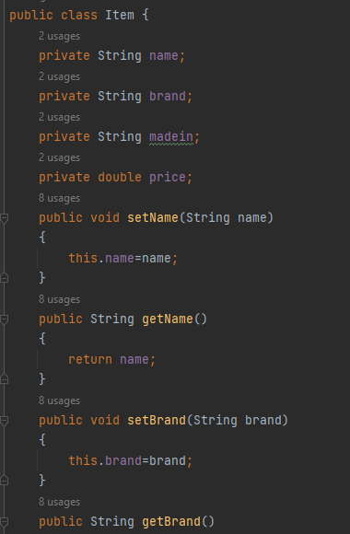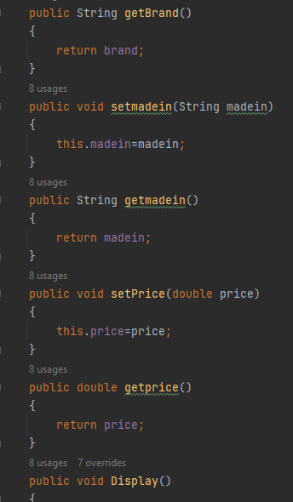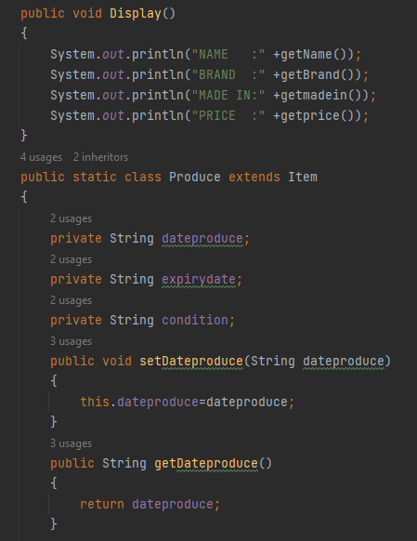

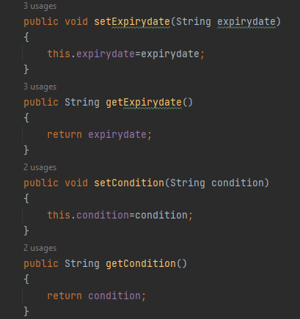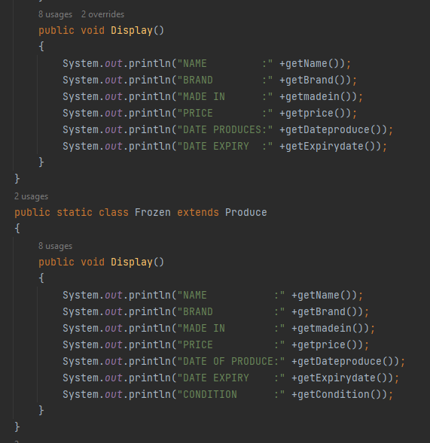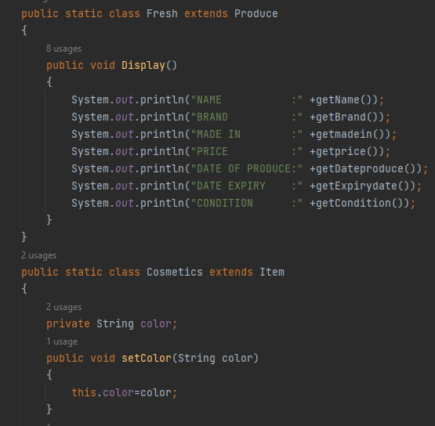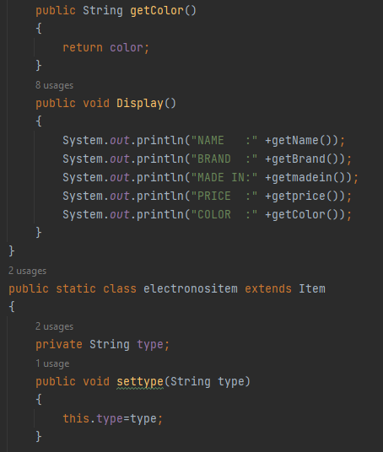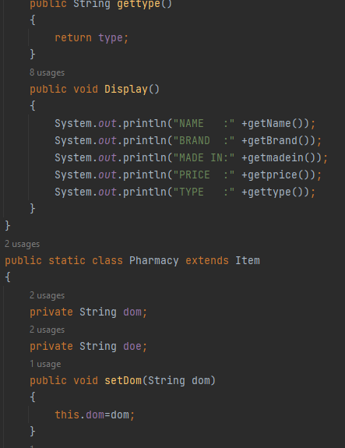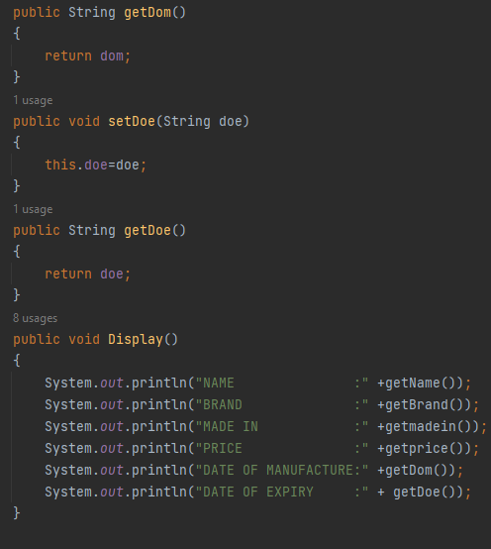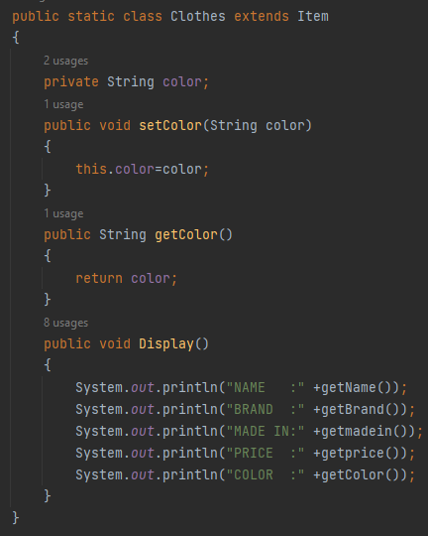

**Output:**

**Task No. 4:** Write a program that inherits a class named Pakistani, BBQ, Chinese, Fast Food and Beverages etc. from a parent class Item. The Item class has its own features like name, quantity, and price etc. the child class inheriting these features like, name and price etc. the child classes inheriting these functionalities as well as they have their characteristics, thus explaining the concepts of inheritance. Child classes have their own classes.

**Solution:**

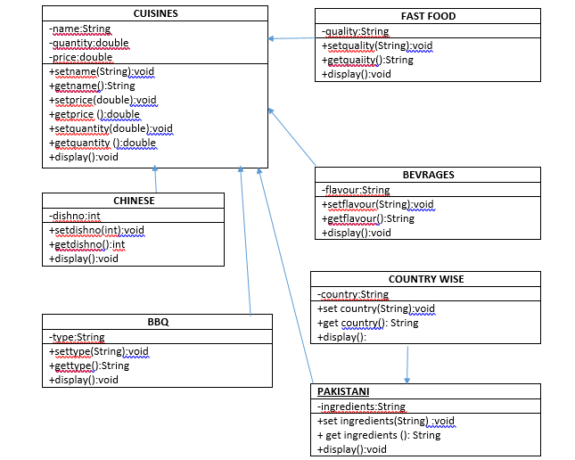

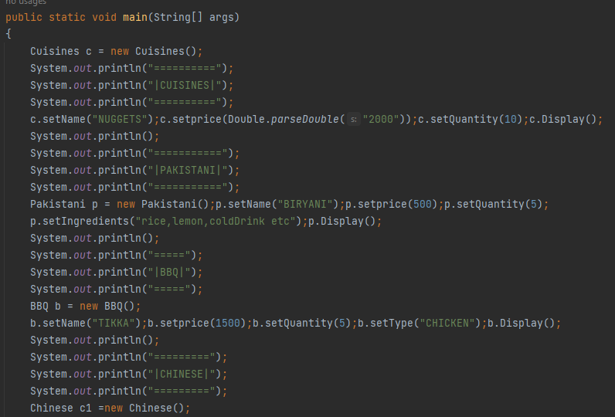

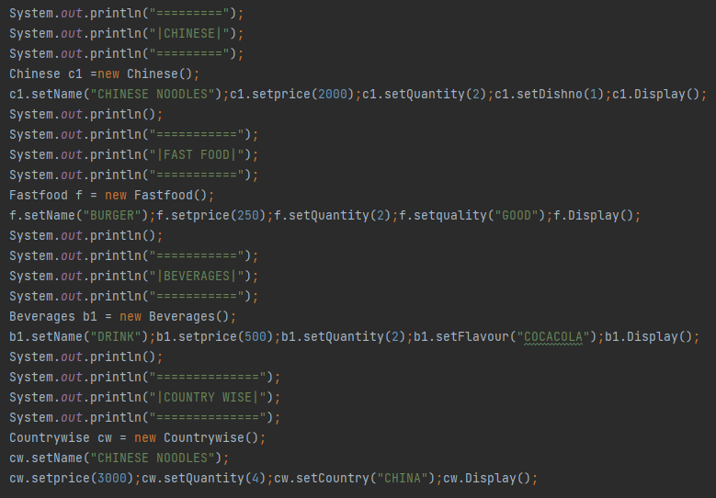

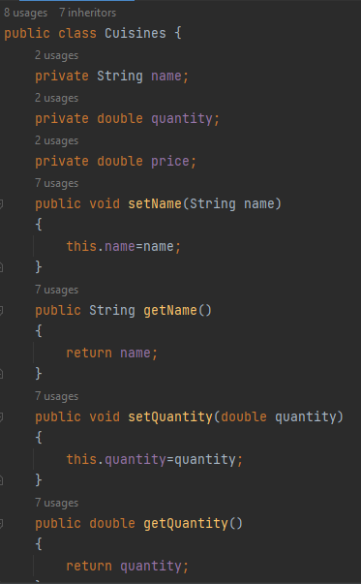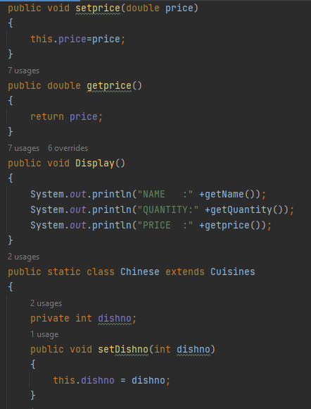

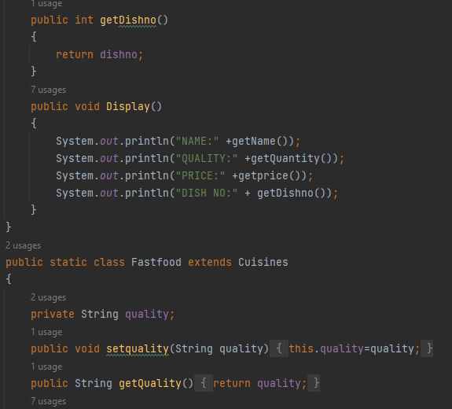 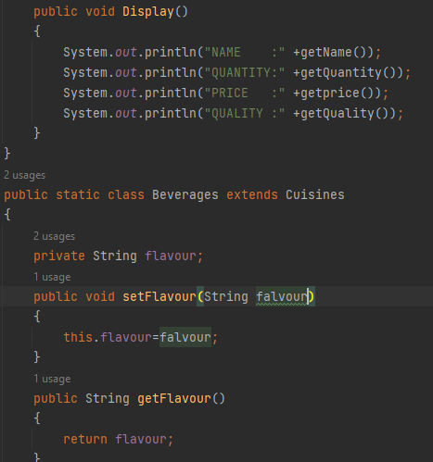 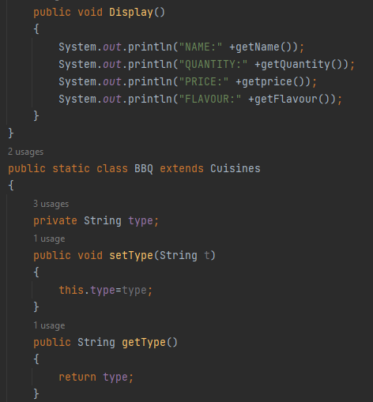

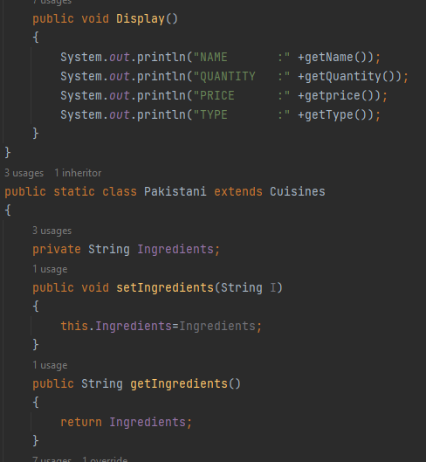 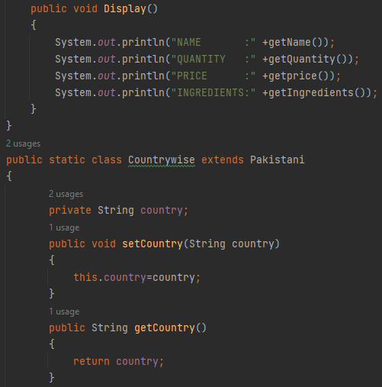 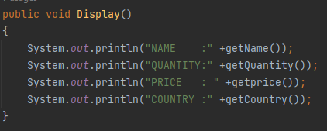

**Output:**

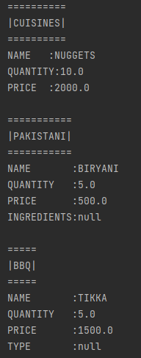 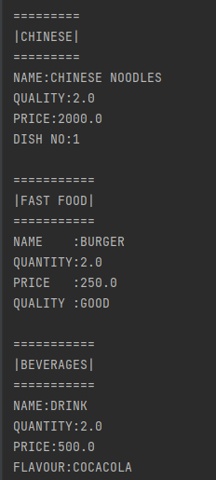 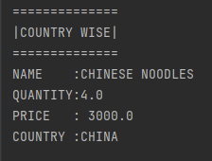

**Task No. 5:** Write code according to the given guide. You must draw a class diagram first to start writing your code.

**Solution:**

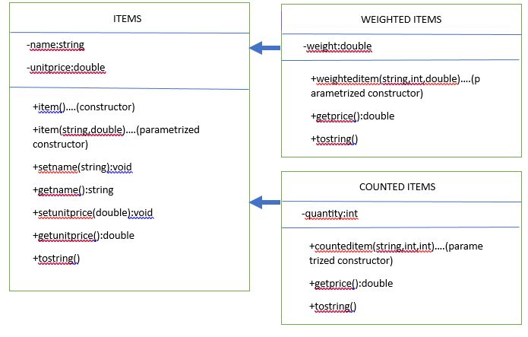

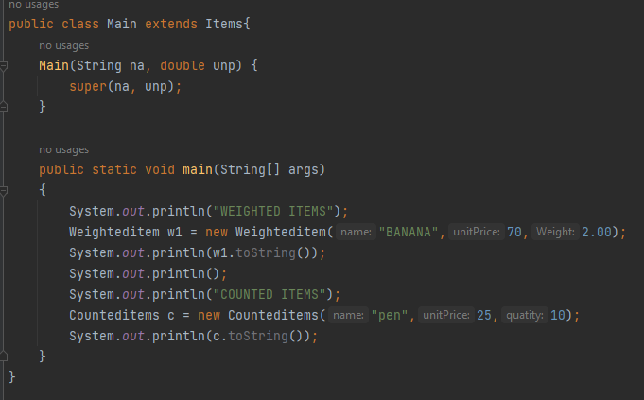

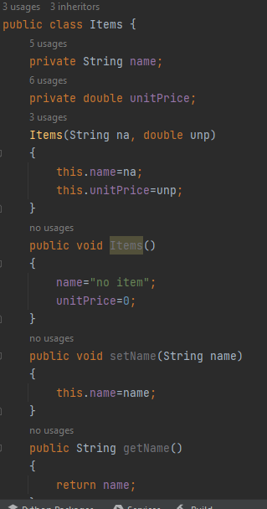 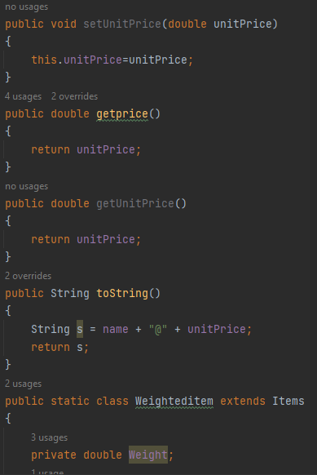 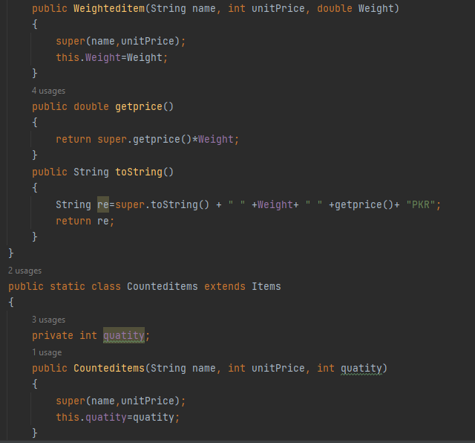 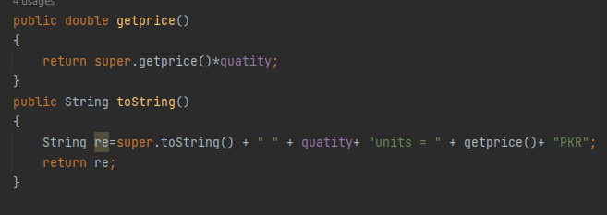

**Output:**

